Wholesale Medicine Database System

Group Members: Syed Soban Ahmed Shah , Muhammad Saad
Program: BS (Ai) “B”
Course: Database Lab
Instructor: Ali Hassan

Milestone | Date | Version | Remarks
ERD Diagram | 4/26/2026 | V1.0
Schema Design | 4/26/2026 | V1.1

- Entity Relationship Diagram (ERD)

Introduction:
The following ERD represents the database design of the Wholesale Medicine Distribution System. It shows the main entities, their attributes, and the relationships between them.

Entities Description:
- Supplier: Stores information about medicine suppliers.
- Medicines: Contains details of all medicines including price and expiry.
- Customers: Stores pharmacy/customer details.
- Orders: Records customer orders.
- OrderDetails: Stores medicines included in each order.
- Inventory: Tracks stock levels of medicines.

Relationships:
- One supplier supplies many medicines (1:M)
- One customer can place many orders (1:M)
- One order contains multiple medicines (M:N via OrderDetails)
- One medicine can appear in many orders
- Each medicine has one inventory record (1:1)
Figure :

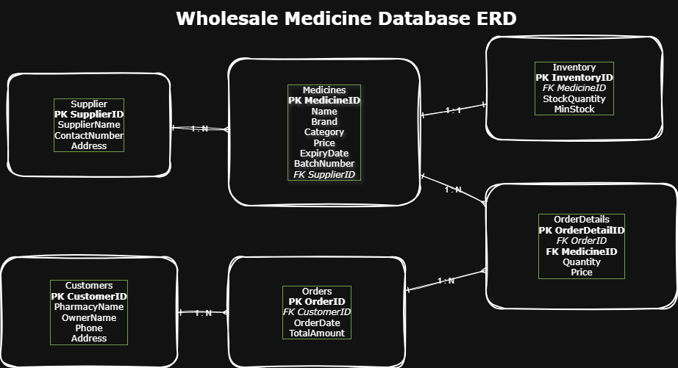

- Relational Database Schema
The following relational schema is designed for the Wholesale Medicine Distribution System. Each table represents an entity, along with its attributes, primary keys (PK), and foreign keys (FK).

- Supplier
Supplier(
SupplierID PK,
SupplierName,
ContactNumber,
Address
)
Description:
This table stores information about pharmaceutical companies or suppliers who provide medicines.
- Medicines

Medicines(
MedicineID PK,
MedicineName,
Brand,
Category,
Price,
ExpiryDate,
BatchNumber,
SupplierID FK
)
Description:
This table contains details of all medicines available in the system. Each medicine is linked to a supplier.

- Customers

Customers(
CustomerID PK,
PharmacyName,
OwnerName,
Phone,
Address
)
Description:
This table stores information about customers, which are pharmacies or medical stores purchasing medicines.

- Orders

Orders(
OrderID PK,
CustomerID FK,
OrderDate,
TotalAmount
)
Description:
This table records each order placed by customers. Each order is linked to a specific customer.

- Order Details

OrderDetails(
OrderDetailID PK,
OrderID FK,
MedicineID FK,
Quantity,
Price
)
Description:
This table stores the details of medicines included in each order. It resolves the many-to-many relationship between Orders and Medicines.

- Inventory

Inventory(
InventoryID PK,
MedicineID FK,
StockQuantity,
MinimumStockLevel
)
Description:
This table tracks the stock levels of each medicine and helps identify low inventory.

